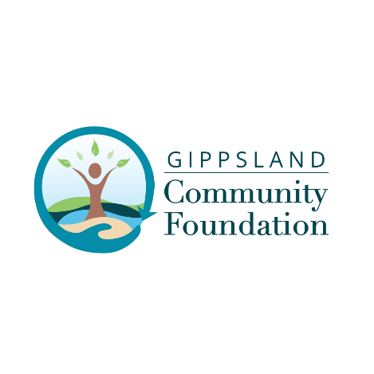
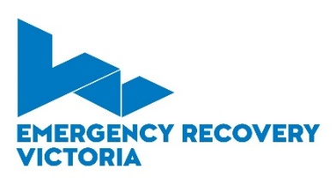
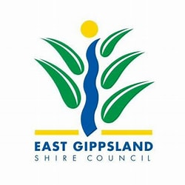

2024 Community Events Grants
Black Summer Bushfire Communities
Funds have been made available by East Gippsland Shire Council and Gippsland Community Foundation with funds from the Victorian Government through Emergency Recovery Victoria and Commonwealth Government, under the Commonwealth-State Category C Disaster Recovery Funding Arrangements, in response to the 2019-20 Eastern Victorian Bushfires.

Please read this information sheet before commencing an application to ensure your organisation is eligible to apply.
Information for Community Event Grants 2024
Who can apply?
Not-for-profit organisations and incorporated entities with a current and valid ABN. Service delivery outcomes must directly benefit residents in East Gippsland Shire locations impacted by the Black Summer Fires of 2019/2020 (refer to districts below).
If your business or organisation wishes to apply for a grant but is not an eligible entity, you will need to establish a relationship with an organisation that fits this criteria and work with them to deliver the activity. We refer to these organisations ‘auspice organisations'.
The Community Event Grant focus is on the ten Community Recovery Committees (CRC) across East Gippsland (formed by Bushfire Recovery Victoria in 2020) and their representative groups. The fire impacted regions are:

Buchan and district Bruthen and district
Cann Valley district Clifton Creek area
Errinundra to Snowy district Mallacoota district
Omeo district Orbost district
Sarsfield area Wairewa district

Funding can be provided directly to the CRC’s, their nominated representative groups or eligible applicants.
If your community event or activity is not in one of the listed CRC areas, or your organisation does not have an existing relationship with one of the CRCs, please contact our Community Liaison Officer Cherie Draper on 0426 537 189 to discuss your options.
What sort of activity funding can my community group apply for?
Up to $5,000 per application that supports community events in any of the following outcomes:
- Community social gatherings
- Personal & community health and wellbeing events
- Preparedness & resilience workshops and events
- Connections through Arts and Sports

CRC-sponsored events that have a strong emphasis on developing resilience and community preparedness may be eligible for a higher level of funding at the discretion of GCF. This type of event will be considered on a case-by-case basis.
If the main purpose of your event is for increased education and training, please refer to the East Gippsland Shire Council who have funds available for leadership and professional services to CRCs in 2024 - Bushfire Recovery and Support Office 5153 9500.
When does the community event need to be delivered?
The event needs to be held in the 2024 calendar. The last date to hold your event is 31st December 2024. For dates in January 2025, please discuss with Community Liaison Officer, below. All events will require to be acquitted within 30 days of your event being held. An acquittal form will be provided with notification of a successful application.
What is the deadline for applications?
Applications will be considered throughout the 2024, until funds are exhausted. However, it is recommended to speak with GCF as soon as you become aware of your desire to hold an event. Regular assessment dates will occur as follows:
Due date for your application | Assessment of Grant by EGCF | Notification of success of application
Lodge application by 12 Feb | 19 February 2024 | 21 February 2024
Lodge application by 11 March | 18 March 2024 | 20 March 2024
Lodge application by 15 April | 22 April 2024 | 24 April 2024
Lodge application by 13 May | 13 May 2024 | 15 May 2024
Lodge application by 10 June | 17 June 2024 | 19 June 2024
Lodge application by 1 July | 8 July 2024 | 10 July 2024
Lodge application by 5 August | 12 August 2024 | 14 August 2024
Lodge application by 9 Sept | 16 September 2024 | 18 September 2024
Lodge application by 7 October | 14 October 2024 | 16 October 2024
Lodge application by 4 Nov | 11 November 2024 | 13 November 2024

If your community event is urgent and needs to be held prior to the above timelines, please contact Cherie Draper, Community Liaison Officer, 0426 537 189 to discuss funding options.

What is the funding pool?
There is $200,000 in the grant pool as of February 2024. Funds will be granted until they are exhausted. In an effort to maintain equity between regions, funds have not been pre-allocated to CRC’s. Instead, each CRC will be asked to discuss with GCF an overall events plan for the year in January/February. Events not listed will still be eligible to apply, but this planning will aim to ensure that all regions have the opportunity to nominate their key community events. Funds remaining outside those key community events will go into the general pool.
If grant funds in this pool are exhausted, the Gippsland Community Foundation may still be able to fund your grant through the East Gippsland Community Bushfire Recovery Fund. Please speak to Cherie Draper, Community Liaison Officer, 0426 537 189.
What is the application process?
If you are eligible to apply, the application form is on our website at www.givetoeastgippsland.org.au/grants All applications will need the written support of your nearest Community Recovery Committee, and quotes to quantify the funds being sought.
If you have remaining questions before you apply, please contact our Cherie Draper, Community Liaison Officer, 0426 537 189 to discuss.
How do I submit my application?
Submit your completed application with your quotes to info@givetoeastgippsland.org.au by the assessment date listed.
If I am successful in obtaining funds, will I need to complete an acquittal?
Yes. There is a simple acquittal document to complete that shows us the benefits your community achieved from the event. Receipts for event expenses will need to be submitted with the acquittal form found on our website at www.givetoeastgippsland.org.au/grants. The acquittal will be due within 30 days of the community event.
Acknowledging funding in your event promotions –
Awarded applications will receive a promotions pack with notification of a successful application. This will include logos, promotion guidelines, and how to acknowledge your funding in marketing and at the event.
Can my community group access more than one community event grant?
Yes, multiple grants can be made to groups from fire impacted communities across East Gippsland. It is preferred that an acquittal for each event is completed before further funds are made available to individual applicants, but this can be determined by EGCF on a case-by-case basis.

